Project Assignment: Deep Learning

Introduction
The objective of this work is to predict churn. The dataset contains the details of a bank's customers and the target variable is a binary variable reflecting the fact whether the customer left the bank (closed his account) or he continues to be a customer. The focus of this report is about prediction: predicting if a client will churn or not will allow to take some actions to prevent churning.

The dataset
The dataset is composed of 13 features + 1 target variables:
- RowNumberRow: Numbers from 1 to 10000
- CustomerIdUnique: Ids for bank customer identification
- Surname: Customer's last name
- CreditScore: Credit score of the customer
- Geography: The country from which the customer belongs
- Gender: Male or Female
- Age: Age of the customer
- Tenure: Number of years for which the customer has been with the bank
- Balance: Bank balance of the customer
- NumOfProducts: Number of bank products the customer is utilising
- HasCrCard: Binary Flag for whether the customer holds a credit card with the bank or not
- IsActiveMember: Binary Flag for whether the customer is an active member with the bank or not
- EstimatedSalary: Estimated salary of the customer in Dollars
- Exited: Binary flag 1 if the customer closed account with bank and 0 if the customer is retained

Data preprocessing
A few features were dropped because they did not contain any useful data for prediction: RowNumberRow, CustomerIdUnique and SurnameCustomer’s
The feature “Estimated salary” was dropped as well, since it is not a real and reliable value, it is just an estimation. The are no missing values (the count for all features is 10000, which correspond to the size of the data set).
There were 2 categorical features: Geography and Gender, which were transformed in ordinal features using LabelEncoder.
From the seaborn pairplot, no clear correlation between features was observed (Figure 1).
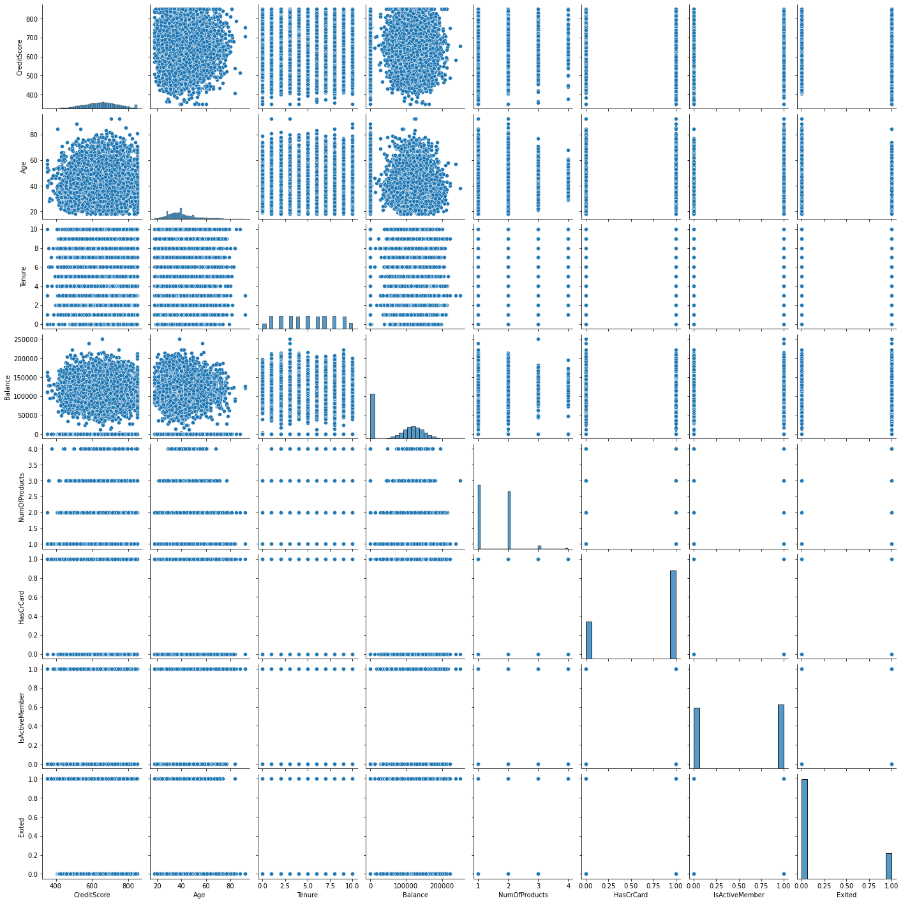
Figure 1: Seaborn pairplot
The target variable is not balanced: the count for not churning is 7963, for churn is 2037. To keep this distribution of the target variable, StratifiedShuffleSplit was used to split the data in training and test set.
Finally, since the features values are not on the same scale, StandardScaler was used to scale them.

Models

Experimental process
Several models were trained (200 epochs), including a RandomForestClassifier (to have a baseline performance) and 3 Deep Learning Models, with different depths and number of units. The accuracy are reported for the validation set.

Results
- RandomForestClassifier(n_estimators=200)
  - Accuracy score: 0.862
  - ROC-AUC: 0.862
- Deep Learning Model 1: One Dense Layer between input and output, 12 units, sigmoid activation
  - Accuracy score: 0.796
  - ROC-AUC: 0.789
- Deep Learning Model 2: Two Dense Layer between input and output, 6 units each, relu activation
  - Accuracy score: 0.796
  - ROC-AUC: 0.842
- Deep Learning Model 3: Two Dense Layer between input and output, 12 units each, relu activation
  - Accuracy score: 0.796
  - ROC-AUC: 0.864
The accuracies for the Deep Learning Models is 0.796, the Deep Learning Model 3 presented the best ROC-AUC. Since the train and validation lost were still descending after 200 epochs, it was trained for 1000 epochs. After training for 1000 epochs, accuracy remains the same, but ROC-AUC increased to 0.872. This is thus the best Deep Learning Model.

Summary, conclusions and perspectives
The best model is Gradient Boosting, with an accuracy of 0.872 on the test set. The model is not overfitting, since the accuracy on the test set is close of the accuracy on the train set, but the model could be biased and the accuracy could be optimized. Other relevant features could be added to examine their influence on the model: for example, professional category or an active loan in the bank (for example, when looking for a loan to buy a house, one person could decide to change bank to have lower interest rates. If someone already has an active loan with his bank, it may be that the probability of churning is lower).
For all models, age seems to be one of the most important features and driving factor. Another important feature, at least for the most accurate models - tree-based), is the number of products. This could be reasonable, since because of laziness or simplicity, if one detains a lot of products in the same bank, it could be more difficult to change bank and open a new contract for new products.
Since the age seems to be a driving factor, it would be interesting to examine more in detail the relationship between age and churn, to discover if some age-range is more prone to churn and design a retention marketing campaign adapted to that specific age range.
The models did not make a distinction between the different geographic locations (France, Spain and Germany). Since every country has its specificities, it could be interesting to train a model for each country to see if there is an effect on the accuracy.

Annexe

